PROJECT REPORT



DEPARTMENT: COMPUTER SCIENCE AND ENGINEERING

Programm: Bachelor Program

Semester Name: Spring-2024

COURSE TITLE: SOFTWARE DEVELOPMENT-1

COURSE CODE: CSE-2340

**Project: Face Recognition-Based Student Attendance System**

**SUBMITTED TO**

FARZANA TASNIM

Lecturer,IIUC

Computer Science and Engineering

**SUBMITTED BY**

NAME: NAZRANA NAHREEN

SEMESTER: 3rd

STUDENT ID: C231444

SECTION: 3BF

# **INTRODUCTION**

With every passing day, we are becoming increasingly dependent on technology for carrying out even the most basic tasks. Facial detection and recognition technologies offer numerous benefits, from sorting photos in our mobile phone galleries to unlocking phones with a mere glance and integrating facial images into national biometric ID databases for verification purposes.

This project aims to implement Face Detection and Face Recognition using Intel’s Computer Vision library, OpenCV. It provides a practical implementation of these technologies using Python on both Windows and macOS platforms. The project's goal is to enable Facial Recognition for faces that the script can be trained to recognize. The input is taken from a webcam, and the recognized faces are displayed along with their names in real time.

On a larger scale, this project can be developed into a biometric attendance system, significantly reducing the time-consuming process of manual attendance systems.

# **PROJECT OVERVIEW**

The project consists of an admin panel and a student panel, both of which interface with a MySQL database for data storage and retrieval. The project uses Tkinter for both frontend and backend development. The system's primary function is to save student data and take attendance based on facial recognition.

Given my limited knowledge of machine learning, I initially used pre-set photos for students to recognize their faces. The system components and their functionalities are detailed below.

**TECHNOLOGIES USED**

**Frontend and Backend Development:**

**Tkinter:** Used for creating the graphical user interface (GUI) for both the admin and student panels.

**PIL (Python Imaging Library):** Used for image processing and handling image-related tasks within Tkinter.

**Database(MySQL):** Used for storing and retrieving student data and attendance records.

**Face Recognition:**

**OpenCV:** Intel’s Computer Vision library used for implementing face detection and recognition.

**Additional Libraries:** face_recognition: A library built on top of dlib’s facial recognition functionality.

**SYSTEM ARCHITECTURE**

**1. Admin Panel:**

**Functionality:**

* Login and Registration system for secure access.
* Interface to add, update, and delete student records.
* Viewing and managing attendance records.

**Modules:**

Admin: Handles the admin functionalities.

Train: Trains the face recognition model with the student dataset(which has been rest for developing in future).

Developer: Provides information about the developer and project.

Help: Offers help and documentation for using the system.

**2. Student Panel:**

**Functionality:**

* Student login and registration.
* Viewing personal attendance records.

**Modules:**

**Student:** Manages the student functionalities and interactions.

**TAKEATTENDANCE:** Captures attendance by recognizing student faces via webcam.

**3. Face Recognition System:**

**Functionality:**

* Captures video input from the webcam.
* Detects and recognizes faces in real-time.
* Displays recognized faces with their corresponding id.

**Modules:**

FaceRecognition: Core module for face detection and recognition.

**IMPLEMENTATION DETAILS**

**Database Schema:**

**Tables:**

students (student_id, name, department, photo_path, etc.)

attendance (attendance_id, student_id, date, status, etc.)

**Screenshots of project output**

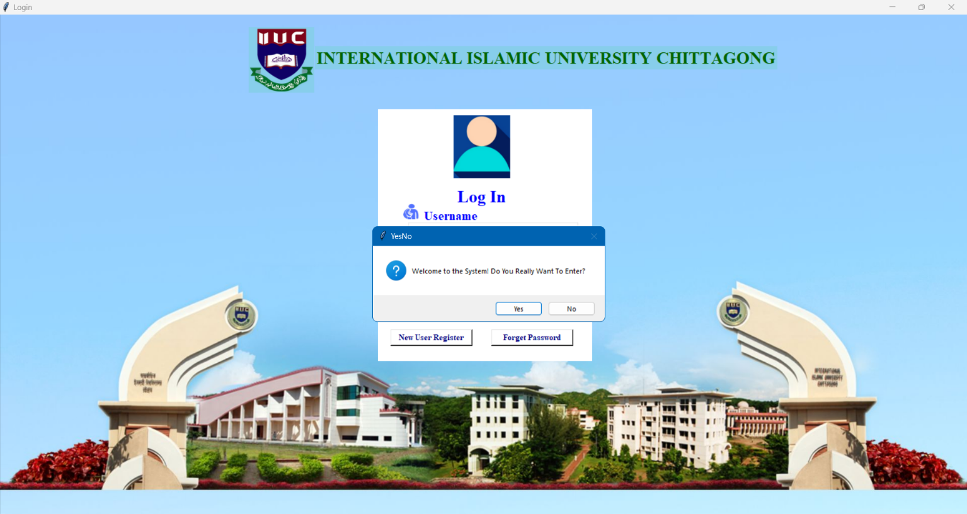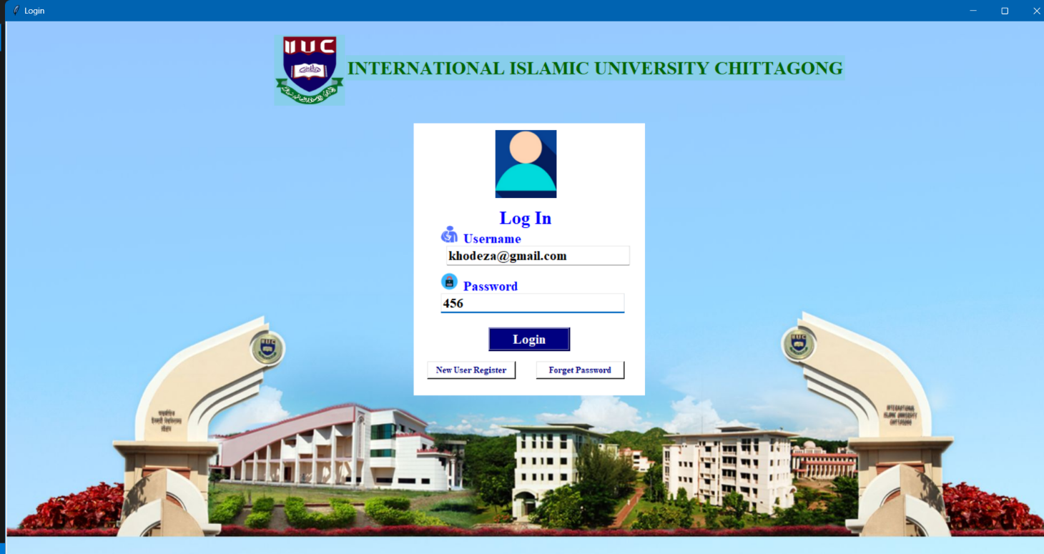

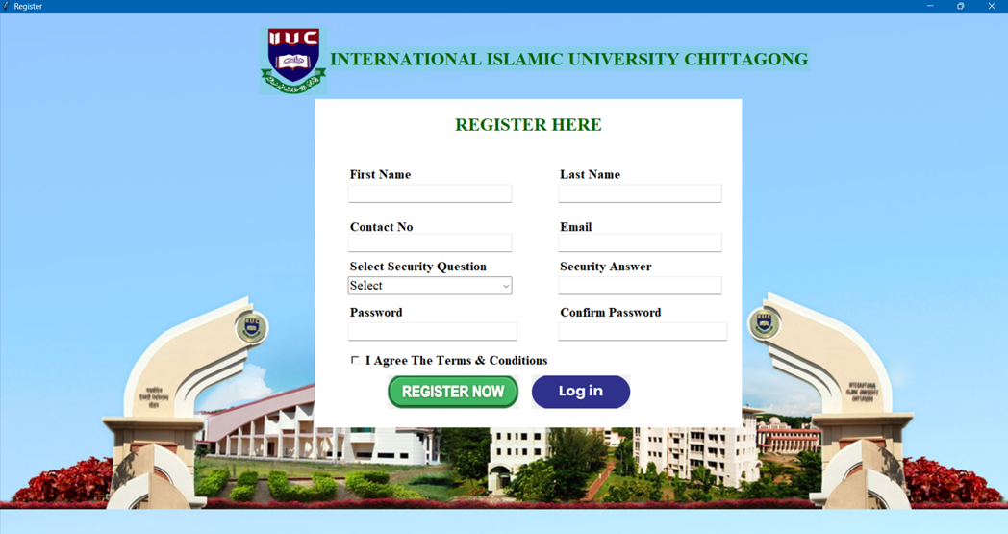

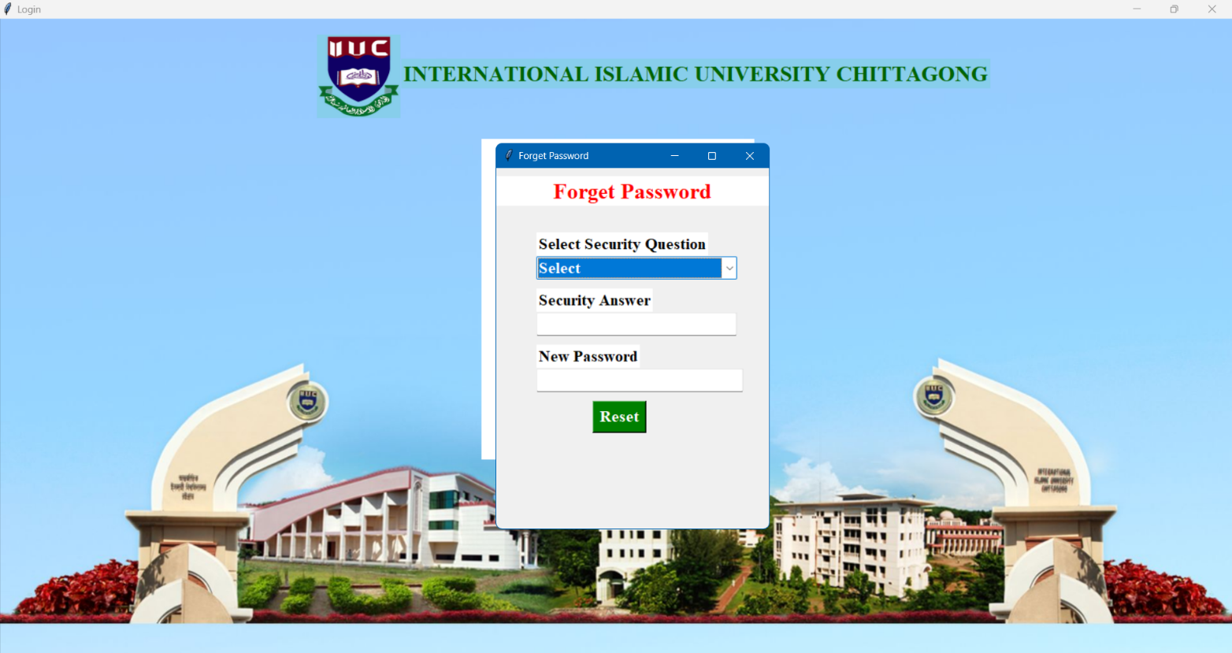

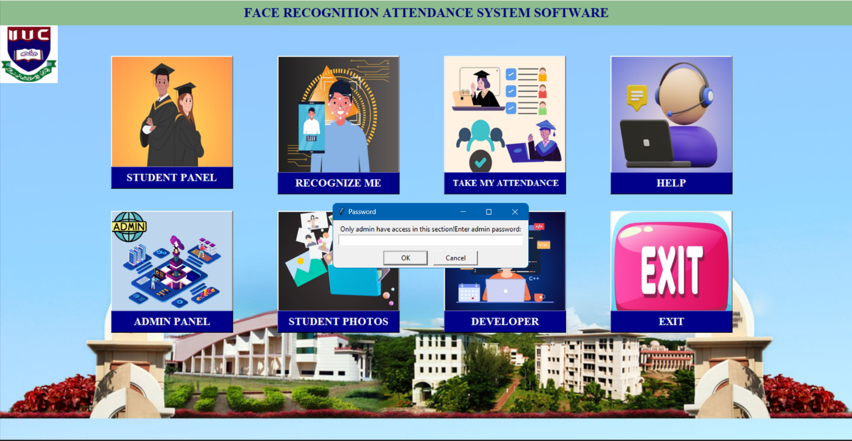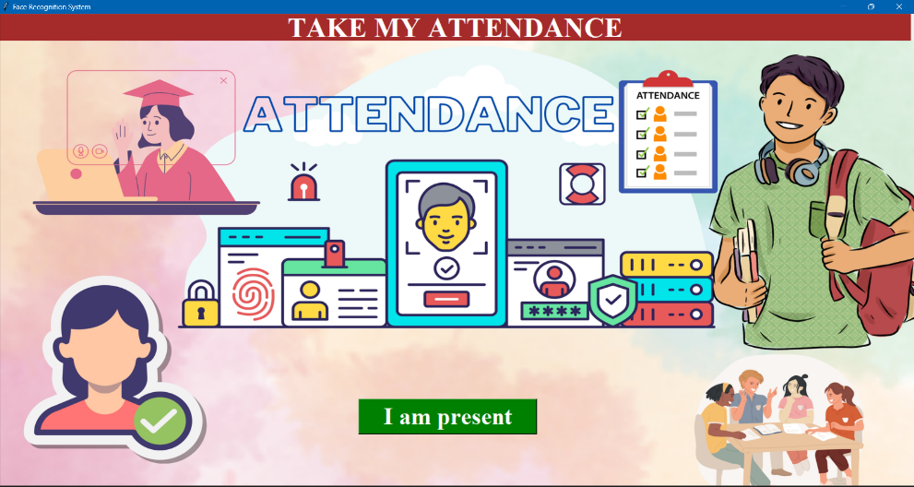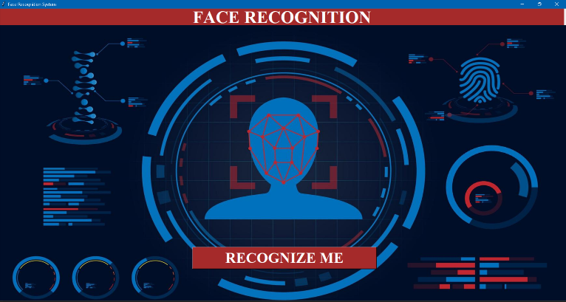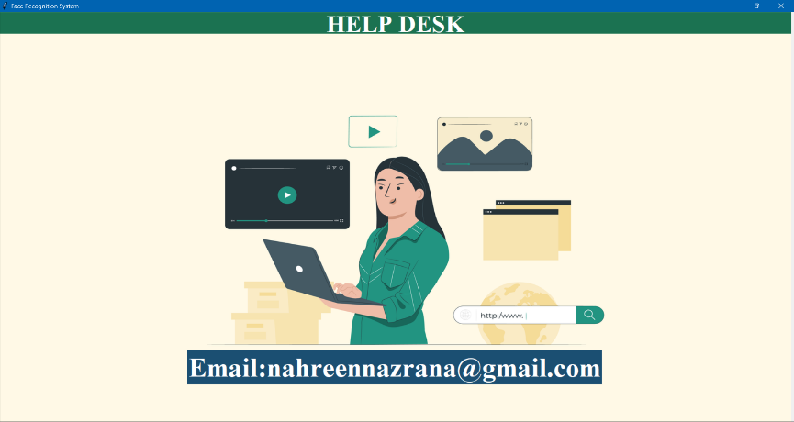

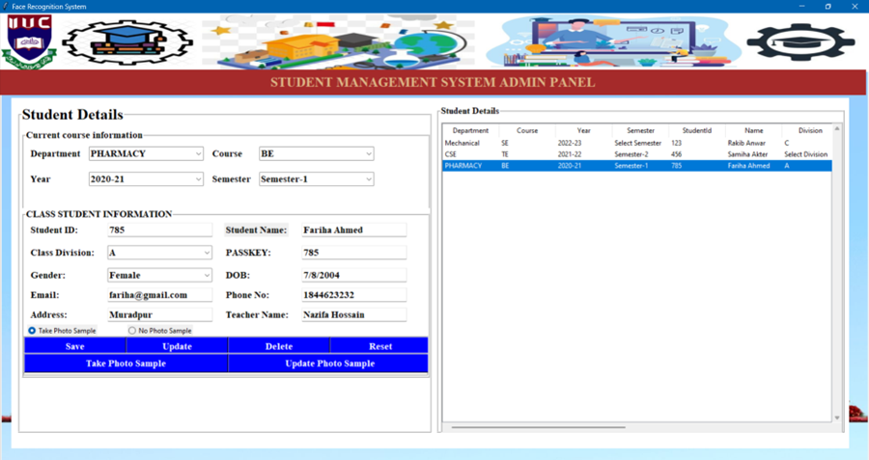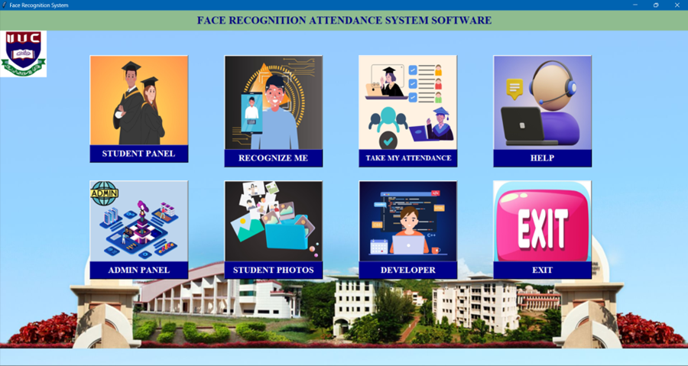

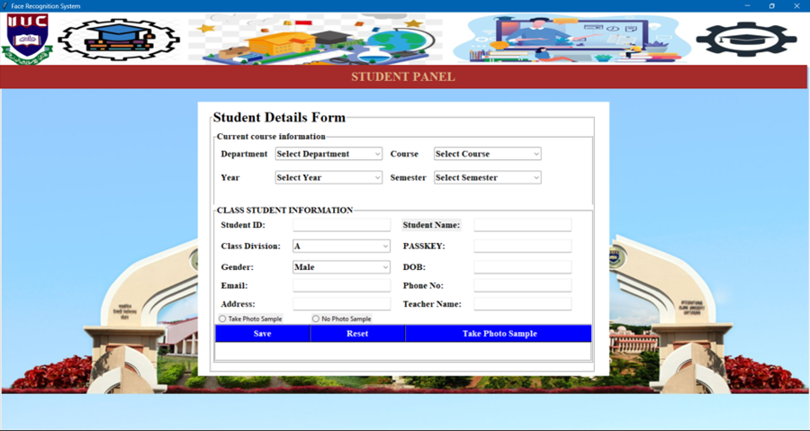

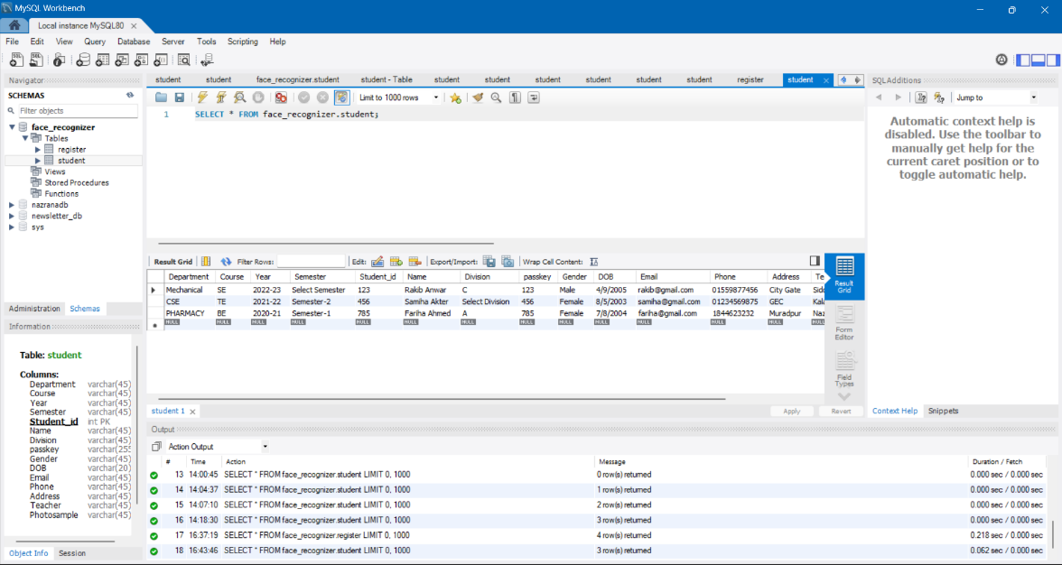

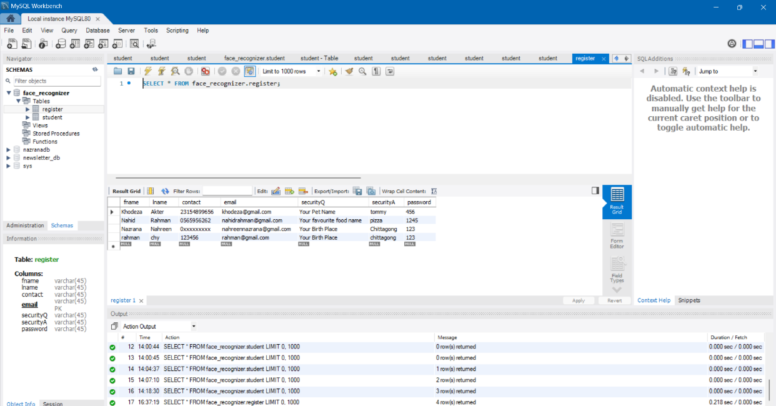

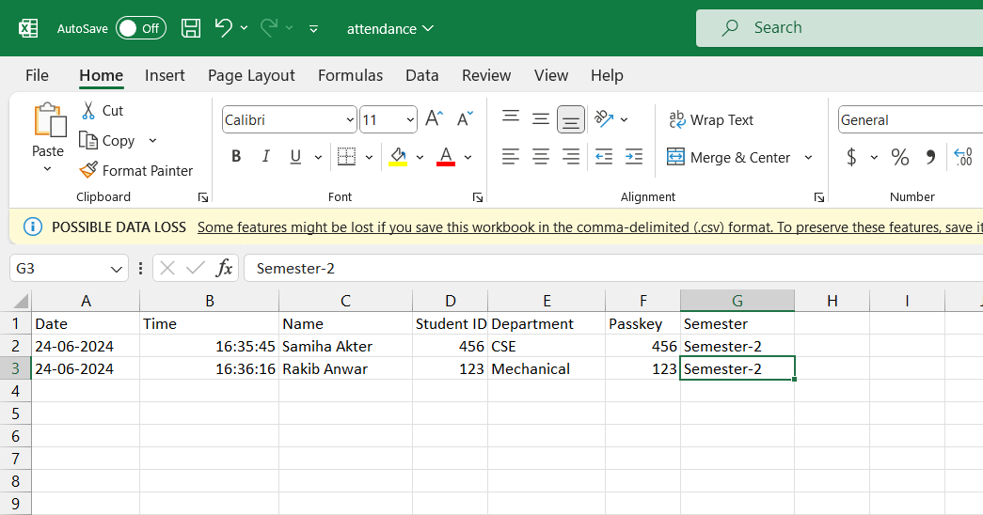

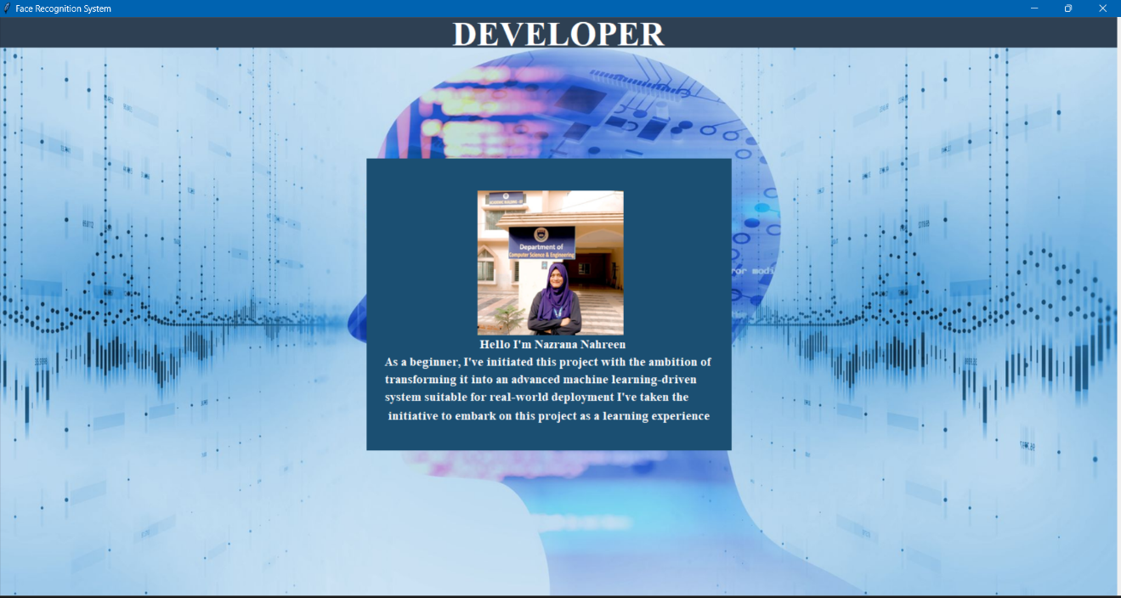**FUTURE WORK**

The current implementation relies on pre-set photos for face recognition. Future work could involve: Integrating a machine learning model for improved accuracy.Implementing real-time model training to adapt to new student photos dynamically.Enhancing the security features of the system.Expanding the system for use in other applications, such as access control.

**CONCLUSION**

This project successfully demonstrates the implementation of a Face Recognition-based Student Attendance System using OpenCV and Tkinter. By automating attendance recording, the system saves time and reduces manual errors. Despite initial limitations in machine learning expertise, the project showcases a functional solution that can be further enhanced and scaled for broader applications.